**S-101PT3-5.1**

## Paper for Consideration by S-101PT3

## M_CSCL and DataCoverage

|  |  |
| --- | --- |
| ***Submitted by:*** | Australian Hydrographic Office |
| ***Executive Summary:*** | Amend the S-101 DCEG regarding the maximum number of DataCoverage features. |
| ***Related Documents:*** | S-57 Appendix B.1 Annex A (UOC) clause 2.2.6, S-101 Appendix A (DCEG). |
| ***Related Projects:*** |  |

## Introduction / Background

As mariners become more familiar with ECDIS and its use, especially in restricted areas, it became clear that traditional bathymetric compilation practices, aimed to represent depths on a ‘static’ product like paper charts, are insufficient to support the full potential digital navigation brings to the bridge of modern vessels.

Based on this, it is AHO’s standard practice to encode multiple compilation scale areas (M_CSCL) within the same navigational purpose ENC product. This is mainly done in approaches to port and along main traffic areas. The intention is to provide mariners with a smooth transition, from waiting (anchorage) areas to berth by connecting these ends by a series of M_CSCL areas with stepped compilation scales based on selectable radar ranges as recommended by the IHO.

## Analysis/Discussion

Current chart compilation practices by an increasing number of HOs are supporting the ‘ENC first’ concept. This means charts are compiled to serve the purpose and display characteristics of ENCs and not paper charts’.

One of the benefits of electronic navigation is the interaction between a ship’s position (obtained from GNSS) and the information encoded in the charts (e.g. ENCs). It’s possible to set ECDIS to automatically ’zoom in’ when larger compilation scale data is available. This can be the consequence of the existence of a larger scale product or a larger compilation scale area within the same product (M_CSCL).

At the AHO we have been using multiple compilation scales areas within the same product since a ‘tiled’ product scheme was implemented for the NP 1 to 4 ENCs back in the early 2000’s.

At that time ENCs were derived from the existing portfolio of paper charts and each ENC tile was made of the largest scale products available. For example AU411142 contains the data shown in 37500, 75000 and 150000 paper charts and its compilation scale (CSCL) was selected from the smallest scale paper chart included in the puzzle and based on the IHO recommended ‘radar ranges’ values (90000 for a 150k paper chart).Please notice that a ‘non-standard’ CSCL value of 18000 was also selected as the best scale range for the data sourced from a 37500 paper chart.

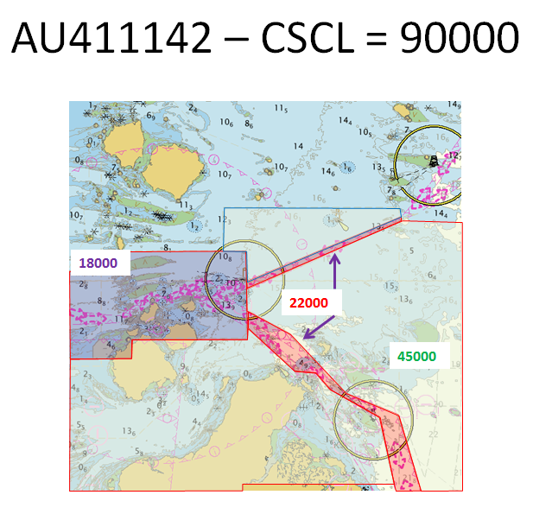

## In the last 5 years or so the AHO started to include larger compilation scale areas in some ENCs (AU5 and AU4) to improve electronic navigation using ECDIS without any direct impact on paper charts. An example of this can be seen in the image above where a 1:22000 M_CSCL was created along the TWR up in Torres Strait (Great Barrier Reef). This area includes more soundings and detailed standard contours and gives more room for ships to visualize crossings, etc.

Please notice that some other countries such as the US (NOAA) have encoded some ENCs with M_CSCL features at a smaller scale than the CSCL value of the ENC.

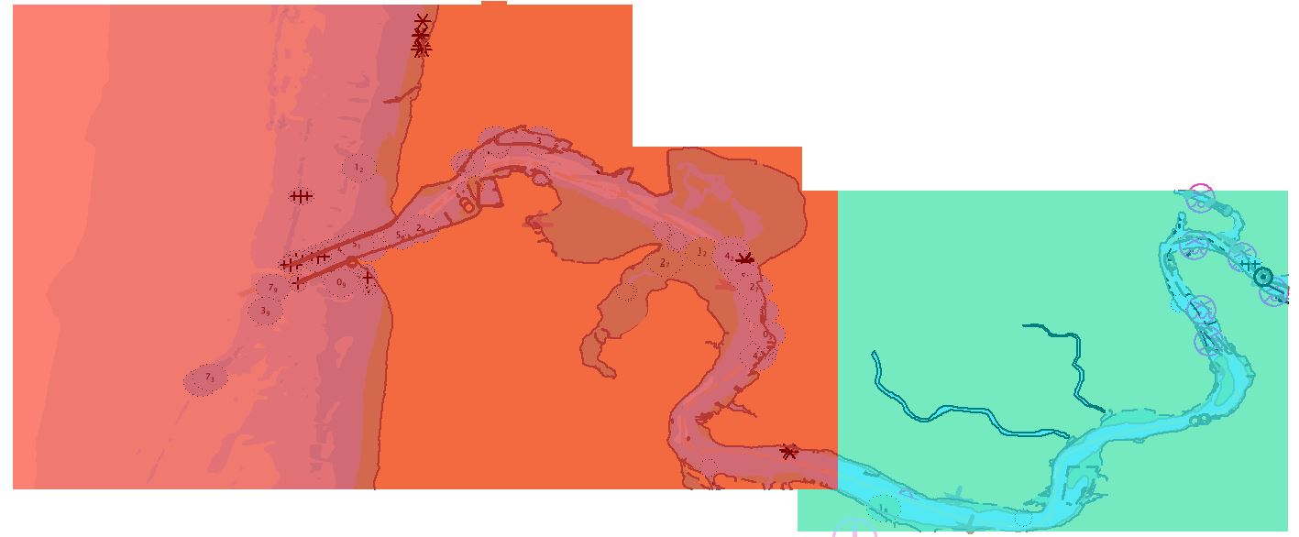

M_CSCL  
CSCALE = 25000

**US5OR44M** CSCL = 10000

**S-101 and ‘DataCoverage’:**

The way ‘DataCoverage’ objects in S-101 (DCEG 3.4) function would appear to improve and standardise the way different compilation scales are used in the same ENC product.  
The attributes ‘minimumDisplayScale’ (minDS) and ‘maximumDisplayScale’ (maxDS) are mandatory and ‘minimumDisplayScale’ must be the same for the whole ENC product.  
  
While using the S-57 to S-101 converter (available to S-100WG members in Basecamp), the AHO noticed that M_COVR is converted into a ‘DataCoverage’ feature and minDS is set to one scale range smaller than CSCL and maxDS to CSCL. Similarly M_CSCL objects are converted into S-101 ‘DataCoverage’ features with minDS equal to the value set for the Data Coverage feature generated from M_COVR and maxDS is set to the value of the corresponding CSCALE attribute.  
  
The methodology currently used by the converter presents some problems:

* The ‘DataCoverage’’feature corresponding to M_COVR always overlaps the ones derived from M_CSCL objects.
* If a country has an M_CSCL with a CSCALE value smaller than CSCL (e.g. NOAA) the maxDS of this features is set to a value which is smaller than minDS
* If CSCL or CSCALE values do not correspond to one of the IHO’s accepted scale ranges, the software automatically ‘rounds them down’ to match one.

Another topic the AHO would like to be discussed is the current guidance in S-101 DCEG (0.0.2) regarding the maximum number of ‘DataCoverage’ areas.

The current S-57 UOC guidance (2.2.6 Compilation scale - Remarks) states as follows:

## *‘The use of too many M_CSCL objects within the same ENC cell should be avoided. The values for the attribute CSCALE of any M_CSCL object should be populated using the same criteria as those used for setting the default compilation scale for the cell.’*

The latest version of the S-101 DCEG (0.0.2) has a more strict approach to the use of the DataCoverage object. It states:  
  
‘*Producing Authorities are to note, however, that excessive use of multiple Data Coverage**features having different values of maximum display scale**within a single dataset* ***must*** *be avoided, with a maximum number of* ***3*** *Data Coverage features being permitted.*’

The AHO would like to see this statement reviewed before S-101 DCEG Ed1 is published or treat the statement as guidance only (should instead of must).

**Current status regarding M_CSCL use at the AHO:**

The AHO currently has up to 4 different scale levels encoded in one single S-57 ENC product. This is normally achieved by using 3 different M_CSCL features plus the scale value corresponding to CSCL of the product (metadata).

Below is a summary of the number of M_CSCL per usage.

+---------------------------+

|Usage | M_CSCL Count    |

+---------------------------+

| AU1    | 0                          |

| AU2    | 1                          |

| AU3    | 115                      |

| AU4    | 360                      |

| AU5    | 80                        |

|  |
| --- |
|  |

The following table focus on the number of ENC products currently containing 3 or more M_CSCL objects (remember that M_COVR would be converted to a DataCoverage feature as well, and the total number of these features in the resulting S-101 ENC would increase by one):

|  |  |
| --- | --- |
| **Number of M_CSCL objects**  (Note that an M_CSCL objet could be split in two but refer to the same CSCALE value. e.g. See 45000 M_CSCALE object in AU411142 example above) | **Number of ENCs** |
| 6 | 2 |
| 5 | 2 |
| 4 | 14 |
| 3 | 29 |
|  | **TOTAL = 47** |

## Conclusions

1. The S-57 to S101 converter creates overlapping ‘DataCoverage’ features when at least one M_CSCL object exists in an ENC.
2. The S-57 to S101 converter ‘rounds’ S-57 scale values if they do not match the IHO recommended ones. The AHO thinks the ‘converter’ must not change compilation scale values automatically and it should issue a warning for the HO to check/confirm instead.
3. Unless there’s strong evidence of a negative impact on ECDIS performance, the AHO would like to see the current statement regarding the maximum allowed number of S-101 ‘DataCoverage’ features:
   1. completely removed from the DCEG or
   2. amended to:  
        
      ‘*Producing Authorities are to note, however, that excessive use of multiple Data Coverage**features having different values of maximum display scale**within a single dataset* ***should*** *be avoided. ~~with a maximum number of 3 Data Coverage features being permitted.~~*~~’~~
   3. or, amend the maximum number of ‘DataCoverage’ features permitted to ‘4’. This new number would only be valid if the wording in the statement is changed to refer to the **maximum number of different ‘maximumDisplayScale’ (maxDS) values encoded** and NOT to the total count of DataCovergae features present in an ENC (e.g: 5 DataCoverage features but only 3 different maxDS values).

## Recommendations

1. Review the way the S-57 to S-101 converter deals with M_CSCL objects.
2. Amend the S-101 PS to provide more flexibility in the use of DataCoverage features.

## Justification and Impacts

If action is not taken the AHO and other HO’s will have to undertake very time consuming, complex and expensive refurbishment/re-scheming activities in a large number of existing S-57 products before being able to successfully migrate them into S-101 products.

## Action Required

The S-101PT is invited to:

a. discuss the content of this paper,

b. accept the recommendations